**IoT-Enabled Fall Detection System for the Elderly Using Machine Learning**

Tushar Pati Tripathi   
 School of Electronics and Communication   
 *Vellore Institute of Technology* Vellore, Tamil Nadu  
 [tushartripathi851@gmail.com](mailto:tushartripathi851@gmail.com)

Aiyushi Srivastava  
 School of Electronics and Communication  
 *Vellore Institute of Technology* Vellore, Tamil Nadu  
 [aiyushisrivastava20@gmail.com](mailto:aiyushisrivastava20@gmail.com)

Rohan Joshi  
 School of Electronics and Communication  
 *Vellore Institute of Technology* Vellore, Tamil Nadu  
 [rohan155joshi@gmail.com](mailto:rohan155joshi@gmail.com)

**Dr. Ravi Kumar C.V.  
 School of Electronics and Communication  
 *Vellore Institute of Technology* Vellore, Tamil Nadu** [**ravikumar.cv@vit.ac.in**](mailto:ravikumar.cv@vit.ac.in)

Abstract-Statistically, falls represent a significant risk for individuals aged 65 and above, with data indicating that falls are the primary cause of injury or fatality within this demographic. Studies show that approximately 30% of elderly individuals over the age of 65 experience falls on an annual basis, underscoring the pervasive nature of this issue in the elderly population.

The primary reason for falls in the elderly is often attributed to an instability in the center of gravity of the human body, leading to a lack of balance and symmetry. Addressing this issue, a proposed approach based on the symmetry principle aims to reorganize accidental falls by analyzing critical parameters such as the speed of descent at the center of the hip joint, the angle of the human body centerline with the ground.

The proposed solution outlined in the research paper suggests an innovative approach centered around reorganizing accidental falls through the application of the symmetry principle. Unlike previous studies that predominantly focused on falling behavior, this new method considers the action of individuals standing up after a fall, leading to a higher recognition rate of 97% for detecting fall behavior than the width-to-height ratio of the human body external rectangular.

***Keywords-*** Fall Detection, IoT, Elderly Care, Machine Learning, Arduino, Sensor Fusion

**INTRODUCTION**   
With the global elderly population still on the increase, their safety and welfare have become a top priority for families, caregivers, and medical practitioners. Falling is one of the most prevalent and hazardous risks that pose a threat to senior citizens. Falls are a major cause of serious injuries, disabilities, and even death among the elderly, usually resulting in fractures, head injuries, and long-term health problems. In most instances, the victims cannot get help immediately, resulting in delayed medical care and aggravated consequences. Conventional fall detection strategies, including caregiver monitoring, emergency call buttons, or manual alert systems, frequently fail because of their slow response or the inability of the elderly to use them after experiencing a fall.  In response to these issues, the incorporation of Smart IoT (Internet of Things) technology fall detection solutions have become a viable solution.

A Smart IoT-based Fall Detection System employs cutting-edge sensor technologies, real-time data processing, and wireless communication to track the movements of older adults and automatically identify falls.

After a fall has been sensed, the system interprets the data with machine learning algorithms or set threshold values. The data is sent to a cloud-based service, where it is monitored real-time, and if a fall is validated, immediate notifications are given to responsible caregivers or emergency responders through mobile apps, SMS messaging, or voice assistants for smart homes. The major benefit of IoT-based fall detection systems is that they can work automatically, minimizing the need for manual intervention and providing quicker response to emergency conditions. This project investigates the creation and deployment of a Smart IoT-based Fall Detection System through its design, effectiveness, and influence on elderly care.  Through investigates the creation and deployment of a Smart IoT-based Fall Detection System through its design, effectiveness, and influence on elderly care.  Through the integration of IoT, AI, and real-time monitoring, this system seeks to enhance the quality of life for senior citizens, increase their autonomy, and bring peace of mind to caregivers and family members.

**BACKGROUND**

Falling is the second greatest cause of accidental death through injury globally, responsible for over 684,000 deaths a year (WHO). In those 65 and over, 28–35% have one or more falls each year, and 32–42% among those aged above 70 years. Falling ranks as a top source of hip fracture, head trauma, and hospitalization in older adults.

Conventional systems such as panic buttons tend to consist due to failure to trigger following a fall. Consequently, IoT-based fall detection systems have been developed, using accelerometers, gyroscopes, pressure, and distance sensors to recognize sudden movement, loss of balance, and impact. By incorporating machine learning, the systems can effectively differentiate between genuine falls and routine activities, minimize false alarms, and facilitate immediate alerts to caregivers through SMS, cloud, or mobile applications.

**LITERATURE REVIEW**

Previous research has explored various methods for fall prevention and detection. A study in [1] reviewed multiple interventions for preventing falls in older adults and found several effective strategies but lacked real-time applications. Another work in [2] focused on fall prevention in emergency settings through multifactorial assessments, yet did not involve any hardware-based implementation. In [3], researchers used wearable gyroscopes to classify step, and spin turns to assess fall risk. Although it achieved accurate classification, it depended heavily on wearable devices, which may not always be practical for elderly users.

To overcome these limitations, our project focuses on developing a real-time fall detection system using multiple low-cost sensors connected to an Arduino Uno. Unlike previous works, our system collects data from accelerometers, gyroscopes, pressure, and distance sensors to capture a wide range of movement and environmental information. We preprocess this data using jerk magnitude and resample it into 1-second intervals to improve consistency.

We also use advanced machine learning models, including a CNN-LSTM hybrid, to improve accuracy in detecting actual falls. Our system is designed for real-time use with an alert mechanism and does not rely on wearables, making it more suitable for elderly individuals in home or assisted living environments.

**OBJECTIVE OF THE STUDY**

A Smart IoT-Based Fall Detection System seeks to improve care for the elderly through the use of advanced sensor technology, artificial intelligence (AI), and cloud computing. The following is a clear definition of its major objectives:

1. Design an Automated Fall Detection System

Objective: Develop an intelligent system for the detection of falls without any manual intervention.

- Conventional fall detection systems depend on the elderly person manually pressing an emergency button or shouting for assistance, which might not always be feasible.

2. Improve Real-Time Monitoring and Alerts

Mission: Offer real-time monitoring and immediate notification to caregivers or emergency services upon detection of a fall.

- The system will continuously monitor motion and changes in body posture through sensors.

3. Enhance Detection Accuracy and Minimize False Alarms

Goal: Enhance the accuracy of fall detection while reducing false positives and false negatives.

4. Merge Wearable and Non-Intrusive Sensor Technologies

Goal: Create an adaptable system based on both wearable and ambient sensors to accommodate varying user needs.

5. Ensure User Comfort and Acceptance

Objective: Create a system that is user-friendly, comfortable, and less intrusive for elderly users.

6. Allow Remote Access and Cloud-Based Data Processing Goal: Leverage IoT and cloud computing to enable caregivers and healthcare professionals to remotely access real-time information.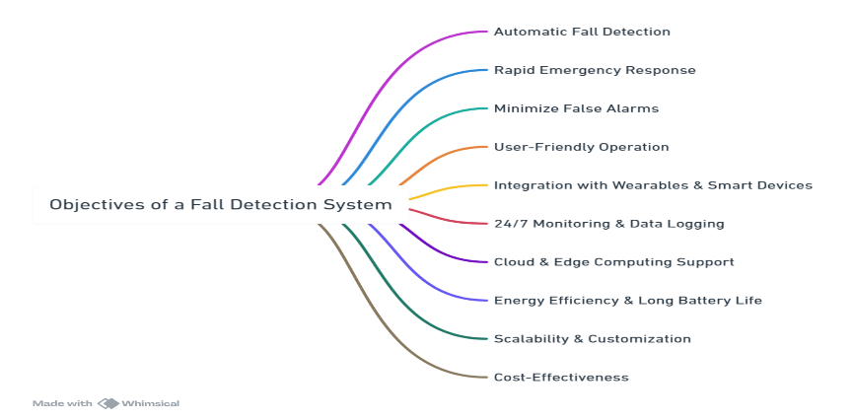

7. Improve Elderly Safety and Independence

Goal: Implement a solution that supports elderly individuals to live independently while maintaining safety.

8. Facilitate Emergency Response and Assistance

Objective: Reduce emergency response time by instantly alerting designated contacts and medical services.

9. Predict Long-Term Movement Patterns for Fall Prevention

Objective: Utilize AI and data analytics to forecast potential fall risks and offer preventive suggestions.

10. Create an Affordable and Scalable Solution

Objective: Ensure the system is affordable, energy-efficient, and easily deployable in various environments.

- Affordability: 

**DIFFICULTIES AND ISSUES**

Challenges and Problems in a Smart IoT-Based Fall Detection System for Elderly

1. Technical Challenges

A. Accuracy and False Alarms

- It is difficult to distinguish between actual falls and normal movements (e.g., rapidly sitting down, bending, or getting into bed).

- False alarms can induce panic among caregivers, whereas ignored falls could result in serious health hazards.

B. Sensor Limitations and Reliability

- Wearable Sensors: Users may forget to wear devices, resulting in non-detection.

C. Real-Time Data Processing and Latency

- IoT-based systems need to process data in real-time to provide instantaneous alerts.

D. Connectivity and Network Dependency

- The system reliably depends on stable internet or cellular connectivity to monitor in real-time.

2. User-Related Challenges

A. Elderly User Acceptance and Compliance

- Lack of Comfort with Technology: Most seniors are not at ease with technology, so they cannot handle IoT-based devices.

B. Variability in User Behavior

- Various older users possess distinctive movement patterns, which cannot be used to design a generic detection system.

3. Cost and Scalability Issues

A. High Initial Cost of Implementation

- Fall detection systems based on AI, cloud computing, and multi-sensor technologies can be costly.

- Wearable devices, IoT hubs, and cloud services add to system costs.

B. Scalability and Maintenance Issues

- Massive deployment in hospitals, nursing homes, or senior care centers involves extensive configuration and maintenance.

- Hardware failure(such as sensor malfunction) can cause system downtime, necessitating frequent maintenance.

4. Security and Privacy Issues

A. Data Security and Cyber Threats

- IoT devices are susceptible to hacking, data breaches, and cyberattacks.

B. Ethical and Legal Issues

- Privacy Laws (HIPAA, GDPR, etc.)– The system should obey healthcare data protection legislation and regulations.

5. Environmental and Deployment Issues

A. Limited Coverage of Sensors

- Environmental sensors (cameras, infrared, pressure sensors) are location-based and can be non-uniform across a house.

6. Emergency Response Challenges

A. Delays in Response Time

- Even in the event of a detected fall, delays in emergency or caregiver response can take place.

**METHODOLOGY**

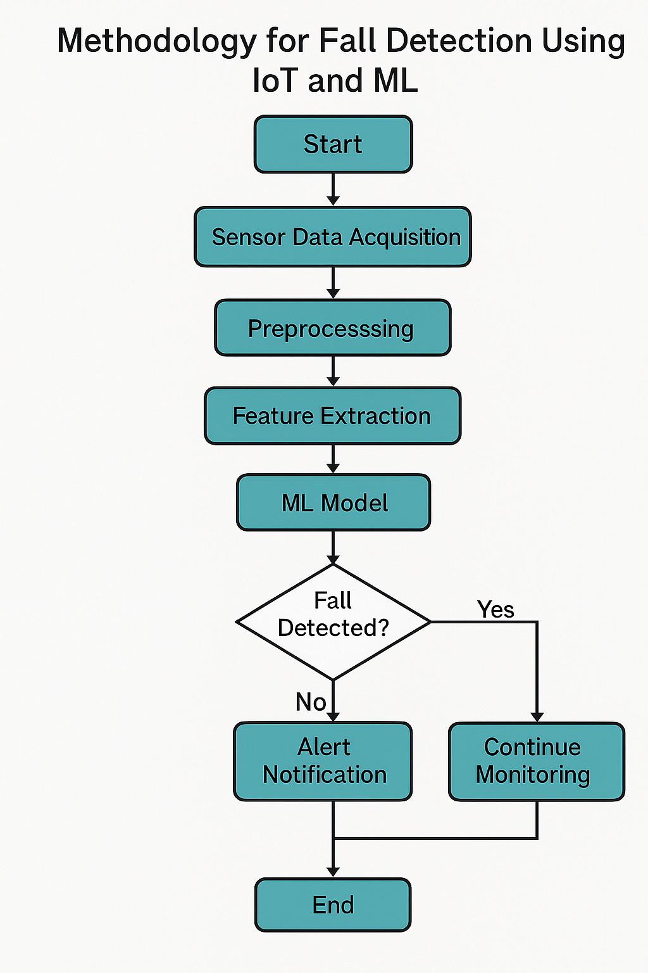

The methodology of this Project includes the following key steps:

1. **Sensor Integration**:

* The system uses the **MPU6050 sensor module**, which includes a **gyroscope and accelerometer** to detect movement and orientation.
* The **Arduino Uno microcontroller** processes data from the sensor.

1. **Data Collection & Processing**:

* Acceleration and angular velocity are calculated from the MPU6050.
* The sum of acceleration vector and angular velocity is analyzed to determine potential falls.

1. **Threshold-Based Fall Detection:** A Lower Fall Threshold (LFT) is established to identify sudden decreases in acceleration. An Upper Fall Threshold (UFT) is established to detect high-impact forces.
2. **Alert Mechanism:** Once a fall is detected, an alert is sent through the Blynk Application on a caregiver's phone.
3. **Prototype Testing**:

* Various test cases, such as front fall, back fall, and side fall, were conducted to verify the system's accuracy.
* Adjustments were made based on real-world test data to improve sensitivity and specificity.

**WORKING**

The **Fall Detection System** using **Arduino UNO and IoT sensors** is designed to continuously monitor the movement and orientation of an elderly person and detect if a fall occurs. Here's how it works, step by step:

1. **Hardware Configuration**

MPU6050, BMP280, and HC-SR04 sensors are mounted on Arduino Uno via I2C and digital pins. Sensors monitor motion, altitude, and distance from the ground in real-time.

2. **Data Gathering from Sensors**

Arduino constantly reads acceleration, gyroscope, pressure, and distance data. Data is displayed on the Serial Monitor for observation and analysis.

3. **Fall Detection Logic**

Falls are detected by an increase in acceleration, a sharp descent in altitude, and lower distance to the ground. Reasonable conditions in Arduino programming mark a fall when these deviations take place simultaneously.

4. Integration with Alert System

When a fall is detected, warnings can be issued using a buzzer, SMS (GSM module), or IoT resources such as Blynk. NodeMCU can be utilized for cloud communication

5. **Data Visualisation**

Sensor data and falls are plotted on tools such as ThingSpeak or Google Sheets to monitor activity, refine logic, and learn patterns.

6. **Machine Learning for Accuracy**

Labeled data are used to train ML algorithms (e.g., KNN, SVM). Such models increase accuracy of detection and can be executed in the cloud or through TinyML on the Arduino.

7. **Testing and Deployment**

The entire system is calibrated using simulated tasks. Depending on performance, thresholds or ML models are fine-tuned. Final configuration can be worn or fixed for use in the real world.

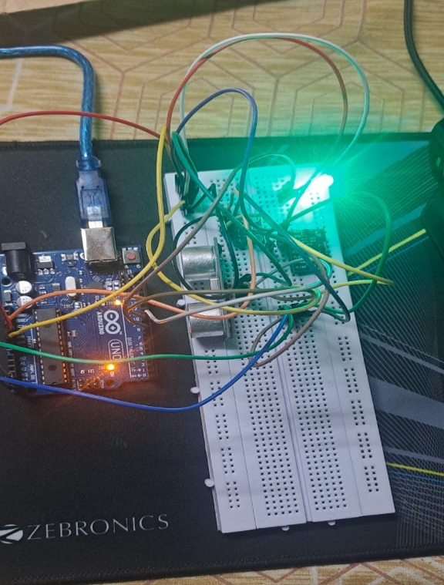

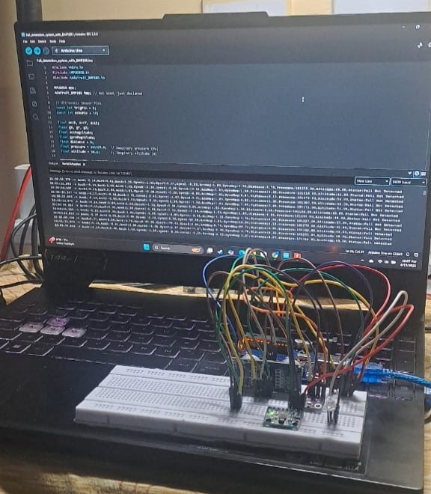

**CIRCUIT DIAGRAM**

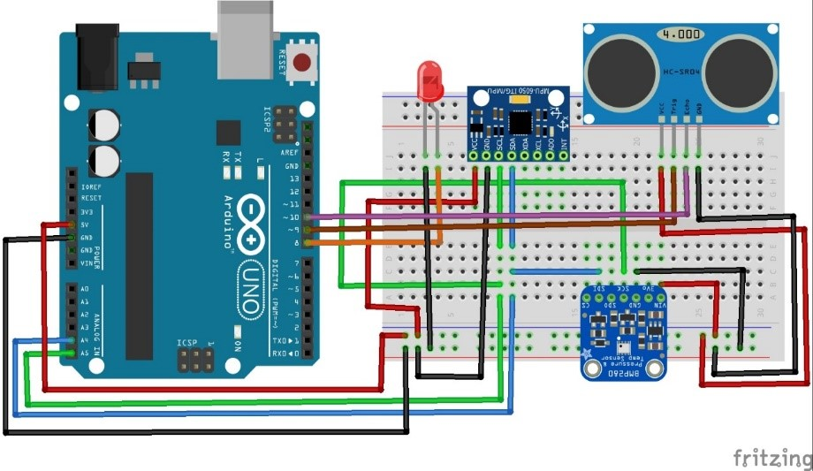

The system uses an Arduino Uno connected to MPU6050, BMP280, and HC-SR04 sensors. The MPU6050 and BMP280 operate over I2C, with SDA and SCL lines connected to A4 and A5, respectively. MPU6050 is powered via 5V, while BMP280 uses 3.3V. The HC-SR04 ultrasonic sensor is powered through 5V, with TRIG and ECHO connected to D8 and D9. An LED indicator is attached to D8 (via a 220Ω resistor) for local fall alerts, with its cathode grounded.

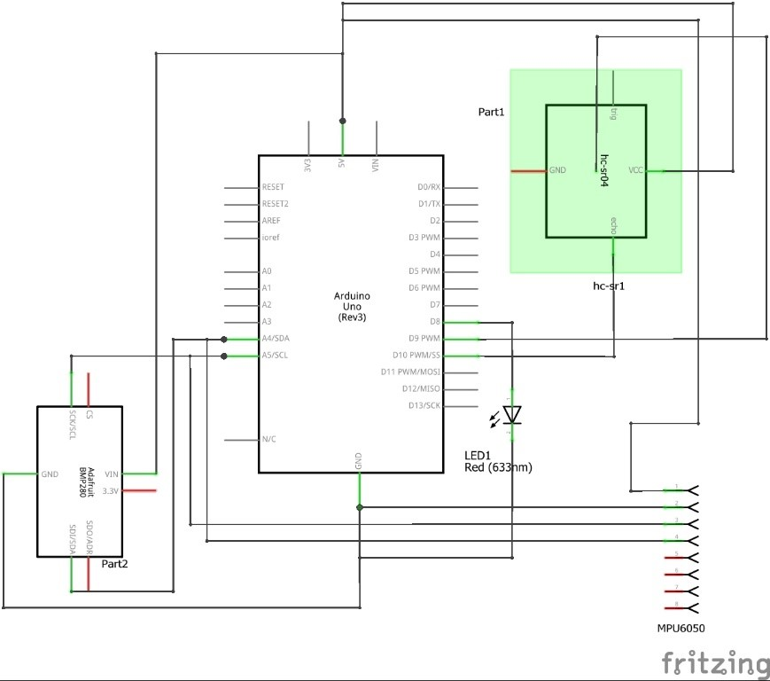

Example:

if (acceleration > FALL_THRESHOLD && orientation_change_detected) {    fallDetected = true

}

**Real Life Example Flow:**

Grandma is walking in the kitchen → she trips and falls →   
 The MPU6050 detects a sharp spike in acceleration and a tilt of 90° →Arduino confirms no movement for 6 seconds →   
 Buzzer rings + SIM800L sends SMS to her son: “Fall Detected at [TIME]. Location: [GPS]. Please respond.”

[ Sensor Senses Motion ]

        ↓

[ Arduino Processes Data ]

        ↓

[ Fall Detected? ]

     ↙       ↘

   No         Yes

               ↓

 [ Trigger Alert: Buzzer + SMS + GPS ]

               ↓

[ Caregiver Notified & Takes Actio

**CALCULATIONS AND APPROXIMATIONS**

The acceleration magnitude (AM) is computed using the following equation:

AM=Ax2+Ay2+Az2AM = \sqrt{A_x^2 + A_y^2 + A_z^2}AM=Ax2​+Ay2​+Az2​​

 Gyroscope Magnitude (GM) Calculation

The gyroscope gives angular velocity readings along the X, Y, and Z axes — often labeled as Gx,Gy,GzG_x, G_y, G_zGx​,Gy​,Gz​ in units like °/s or rad/s.

The Gyroscope Magnitude (GM) is calculated similarly to acceleration magnitude:

GM=Gx2+Gy2+Gz2GM = \sqrt{G_x^2 + G_y^2 + G_z^2}GM=Gx2​+Gy2​+Gz2​​

This gives the total rotational motion intensity.

Jerk Calculation

Jerk is the rate of change of acceleration over time, and it's a good indicator of sudden movement (like during a fall). It is calculated as:

**RESULTS AND DISCUSSION:**

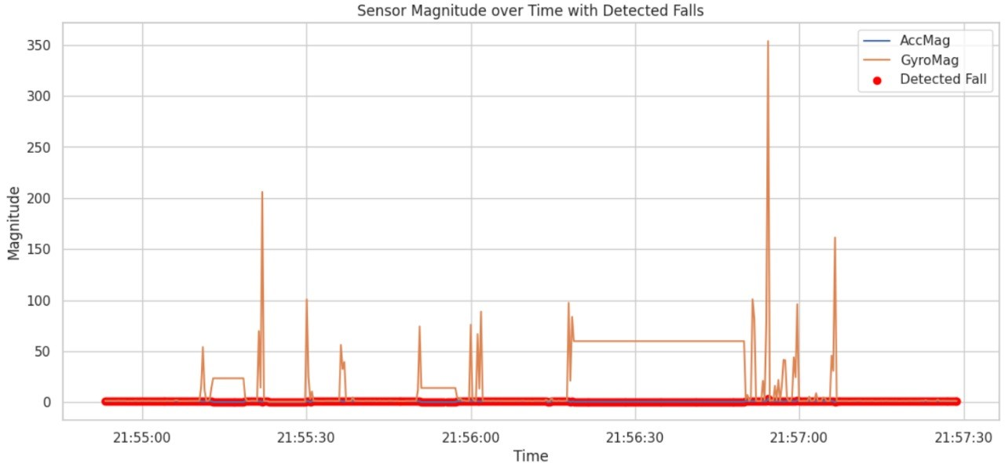

Figure Sensor magnitude over time with detected falls. The plot shows the acceleration magnitude (AccMag), gyroscope magnitude (GyroMag), and fall detection events (red markers).

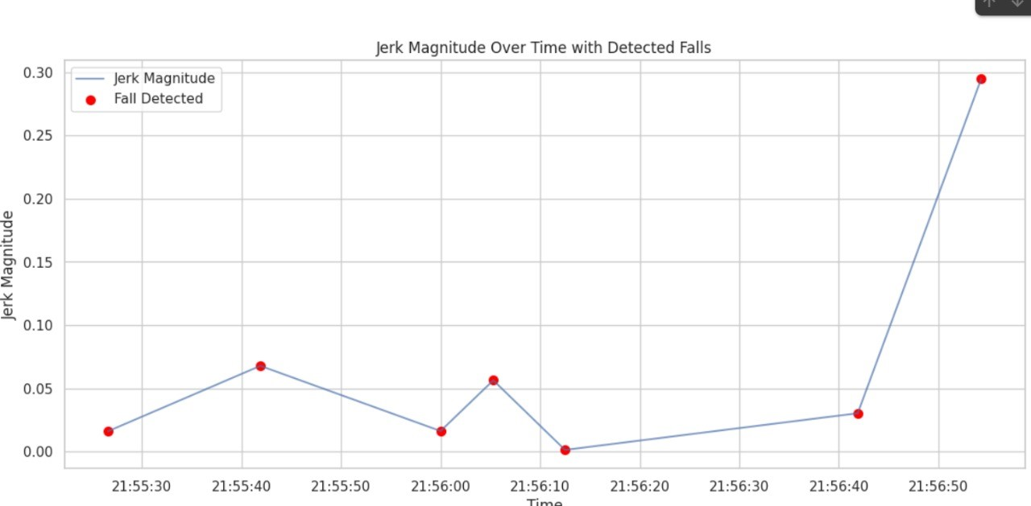

Figure : Jerk magnitude over time with detected falls. The line represents the jerk magnitude calculated from acceleration changes, and red markers indicate identified falls.

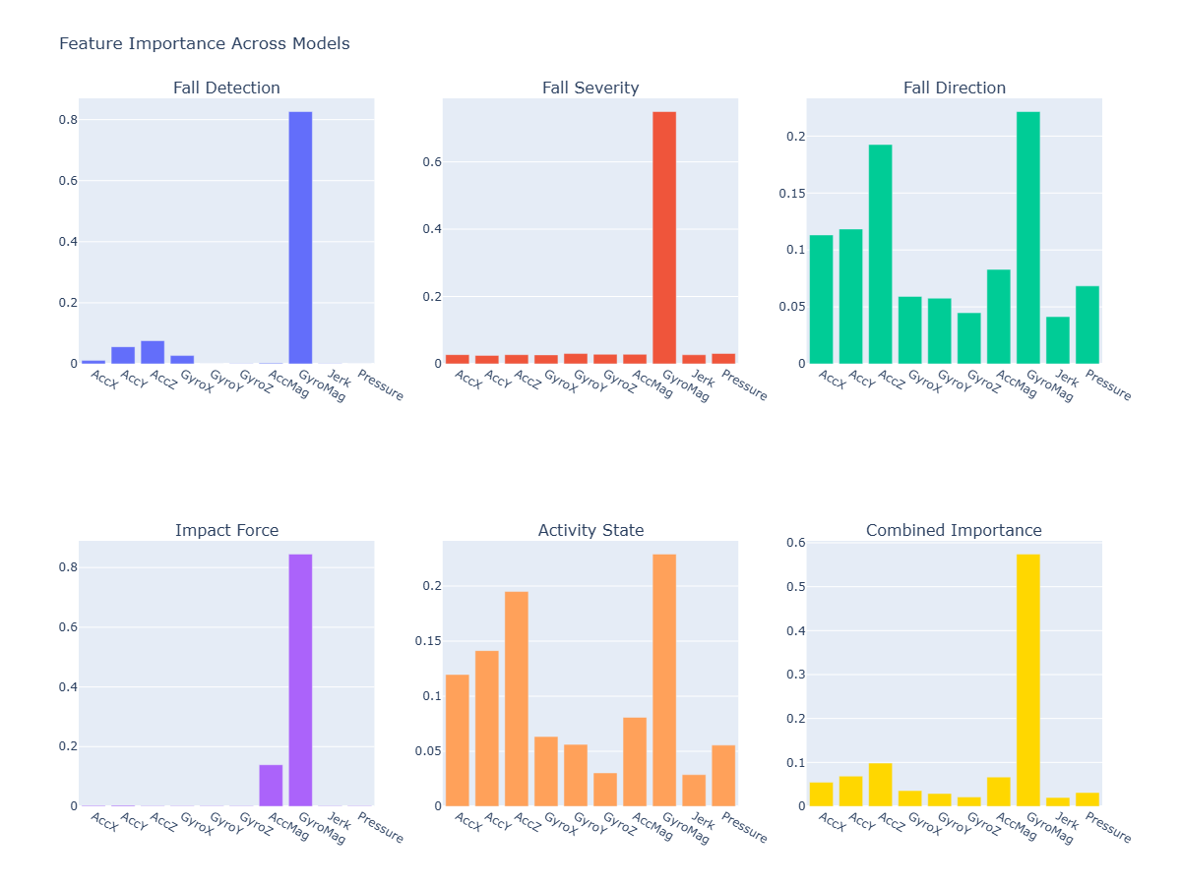

Figure : Feature importance across models. Subplots show the feature contribution for different models: (a) Fall Detection, (b) Fall Severity, (c) Fall Direction, (d) Impact Force, (e) Activity State, and (f) Combined Importance.

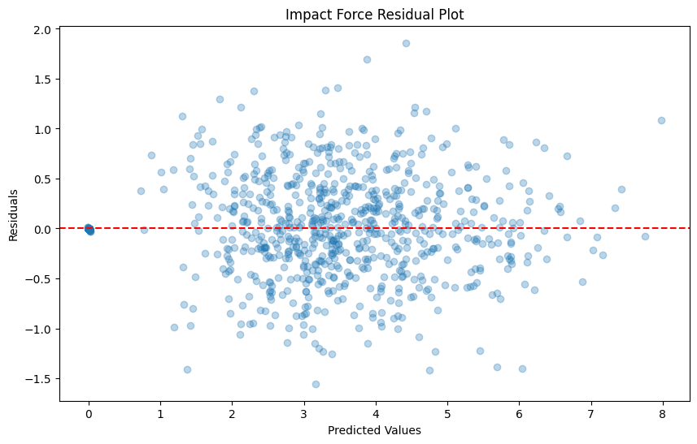

Figure : Residual plot for impact force prediction. The residuals (difference between predicted and actual values) are plotted against the predicted impact force values.

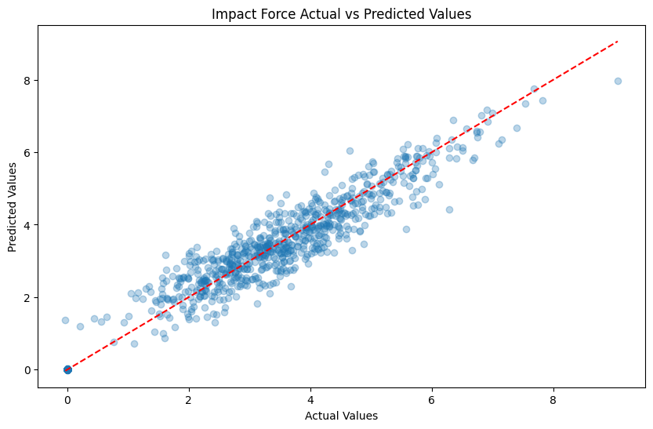

Figure: Actual vs. predicted values for impact force. A strong correlation is observed along the diagonal, indicating good prediction performance of the model.

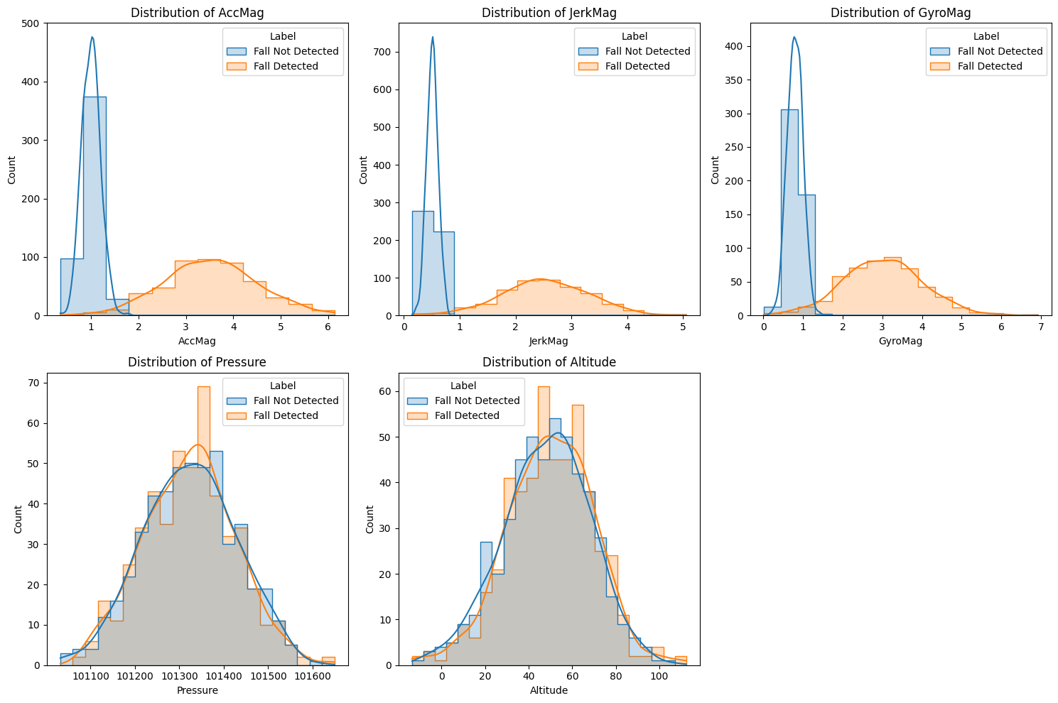

Fig. *Distribution of Features Based on Fall Detection Status*This figure contains five subplots, each showing the distribution of a key feature, comparing instances of fall and non-fall

**CONCLUSION**

The suggested Fall Detection System for the Elderly through Smart IoT and Arduino UNO fills a basic requirement in the healthcare and assisted living industry—providing safety to elderly people who are prone to accidental falls. Incidental falls have the potential to cause severe physical harm, emotional trauma, and in extreme situations, even result in death if not treated early. Therefore, the use of smart sensors in combination with real-time alert mechanisms is an effective early warning system.

The project illustrates how Internet of Things (IoT) and embedded systems technologies can be integrated in a seamless manner to address real-world issues. It's easy to deploy, relatively inexpensive, and customizable based on

user requirements and application environments (e.g., home, nursing homes, or public areas).

In addition, it allows caregivers to remotely monitor the health of older adults, which maintains their autonomy, confidence, and well-being while minimizing the burden on healthcare facilities.

**FUTURE WORK**

Future advancement in fall detection technologies will concentrate on accuracy improvement, minimizing false positives, and enhancing real-time responsiveness. One of the key directions involves the use of edge AI with lightweight ML models (TinyML) that can directly run on microcontrollers, allowing for quicker and offline fall detection. Also, the fusion of multiple types of sensors (e.g., heart rate monitors, temperature, ECG) with motion and altitude information will provide a richer picture of an individual's health and enhance predictability. Utilization of deep learning algorithms, like CNNs and LSTMs, will enable enhanced pattern detection from advanced time-series data. Wearables will continue to shrink, save power, and be comfortable to wear, allowing long-term wearability for seniors. Cloud-based systems may provide real-time monitoring dashboards for caregivers and emergency services, with predictive analytics to predict fall risk based on activity patterns. Next-generation systems might also include voice-assistive AI, GPS location tracking, and automatic emergency responses via smart home integration, providing safety for the elderly in a truly connected setting

**REFERENCE**

Unless there are six authors or more give all authors’ names; do not use “et al.”. Papers that have not been and element symbols. For papers published in translation  journals, please give the English citation first, followed by the original foreign-language citation [6].

1. Faes, M.C.; Reelick, M.F.; Joosten-Weyn Banningh, L.W.; Gier, M.D.; Esselink, R.A.; Olde Rikkert, M.G. Qualitative study on the impact of falling in frail older persons and family caregivers: Foundations for an intervention to prevent falls. Aging Ment. Health 2010, 14, 834–842.
2. Hwang, J.Y., Kang, J.M., Jang, Y.W., Kim, H.C.: Development of novel algorithm and real time monitoring ambulatory system using Bluetooth module for fall detection in the elderly. In: Engineering in Medicine and Biology Society, IEMBS 2004, 26th Annual International Conference of the IEEE, vol. 1, pp. 2204–2207, September 2004
3. B. Najafi, K. Aminian, F. Loew, Y. Blanc and P. A. Robert, "Measurement of stand-sit and sit-and transitions using a miniature gyroscope and its application in fall risk evaluation in the elderly", IEEE Trans. Biomed. Eng., vol. 49, no. 8, pp. 843-851, 2002.
4. National Institute ofNursing Research, Informal Caregiving Research for Chronic Conditions RFA, (2001).
5. E. Mattila, I. Korhonen, J. Merilahti, A. Nummela, M. Myllymaki, and H. Rusko, “A concept for personal wellness management based on activity monitoring,” in Pervasive Computing Technologies for Healthcare,2008. Pervasive Health 2008. Second International Conference on, 302008-feb. 1 20 08, pp. 32 –36.
6. M. Alwan, D. Mack, S. Dalal, S. Kell, B. Turner, and R. Felder, “Impact of passive in-home health status monitoring technology in home health: Outcome pilot,” in Distributed Diagnosis and Home Healthcare, 2006.D2H2. 1st Transdisciplinary Conference on, 2006, pp. 79 –82.
7. Lindemann, U., Hock, A., Stuber, M., Keck, W., Becker, C.: Evaluation of a fall detector based on accelerometers: a pilot study. Med. Biol. Eng. Comput. 43(5), 548–551 (2005)
8. M. Avvenuti, C. Baker, J. Light, D. Tulpan, and A. Vecchio, “Non-intrusive patient monitoring of alzheimer’s disease subjects using wire-less sensor networks,” Privacy, Security, Trust and the Management of e-Business, World Congress on, vol. 0, pp. 161–165, 2009.
9. Kangas, M., Konttila, A., Lindgren, P., Winblad, I., Jämsä, T.: Comparison of low-complexity fall detection algorithms for body attached accelerometers. Gait Posture 28(2), 285–291 (2008) .
10. Abbate, S., Avvenuti, M., Corsini, P., Light, J., Vecchio, A.: Monitoring of human movements for fall detection and activities recognition in elderly care using wireless sensor network: a survey, pp. 1–20. InTech (2010)
11. Zhang, T., Wang, J., Xu, L., Liu, P.: Fall detection by wearable sensor and one-class SVM algorithm. In: Huang, D.-S., Li, K., Irwin, G.W. (eds.) ICIC 2006. LNCIS, vol. 345, pp. 858–863. Springer, Heidelberg (2006)
12. Ganti, R.K., Jayachandran, P., Abdelzaher, T.F., Stankovic, J.A.: Satire: a software architecture for smart attire. In: Proceedings of the 4th International Conference on Mobile Systems, Applications and Services, pp. 110–123. ACM, June 2006
13. Newell, A.; Yang, K.; Deng, J. Stacked hourglass networks for human pose estimation. In Proceedings of theComputer Vision—14th European Conference, Amsterdam, The Netherlands, October 2016; pp. 483–499.
14. Insafutdinov, E.; Pishchulin, L.; Andres, B.; Andriluka, M.; Schiele, B. Deepercut: A deeper, stronger, and faster multi-person pose estimation model. In Proceedings of the European Conference on Computer Vision, Munich, Germany, 8–14 September 2018; pp. 34–50.
15. Jeong, S.; Kang, S.; Chun, I. Human-skeleton based Fall-Detection Method using LSTM for Manufacturing Industries. Proceedings of the 2019 34th International Technical Conference on Circuits/Systems, Computers and Communications (ITC-CSCC), Jeju Shinhwa World, Korea, 23–26 June 2019; pp. 1–4.
16. Chen, T.; Li, Q.; Fu, P.; Yang, J.; Xu, C.; Cong, G.; Li, G. Public opinion polarization by individual revenue from the social preference theory. Int. J. Environ. Res. Public Health 2020, 17, 946.
17. Chen, T.; Li, Q.; Yang, J.; Cong, G.; Li, G. Modeling of the public opinion polarization process with the considerations of individual heterogeneity and dynamic conformity. Mathematics 2019, 7, 917.
18. Chen, T.; Wu, S.; Yang, J.; Cong, G. Risk Propagation Model and Its Simulation of Emergency Logistics Network Based on Material Reliability. Int. J. Environ. Res. Public Health 2019, 16, 4677.
19. Koshmak, G.; Loutfi, A.; Linden, M. Challenges and issues in multisensor fusion approach for fall detection. J. Sens. 2016, 2016.
20. Ramezani, R.; Xiao, Y.; Naeim, A. Sensing-Fi: Wi-Fi CSI and accelerometer fusion system for fall detection. In Proceedings of the 2018 IEEE EMBS International Conference on Biomedical & Health Informatics (BHI), Las Vegas, NV, USA, 4–7 March 2018; pp. 402–405.
21. Cao, Z.; Simon, T.; Wei, S.-E.; Sheikh, Y. Realtime multi-person 2d pose estimation using part affinity fields. In Proceedings of the IEEE Conference on Computer Vision and Pattern Recognition, Honolulu, HI, USA, 21–26 July 2017; pp. 7291–7299.
22. Shiba, K.; Kaburagi, T.; Kurihara, Y. Fall detection utilizing frequency distribution trajectory by microwave Doppler sensor. IEEE Sens. J. 2017, 17, 7561–7568.
23. Fan, K.; Wang, P.; Hu, Y.; Dou, B. Fall detection via human posture representation and support vector machine. Int. J. Distrib. Sens. Netw. 2017, 13, 1550147717707418.
24. . Liu, Y.; Wang, N.; Lv, C.; Cui, J. Human body fall detection based on the Kinect sensor. In Proceedings of the2015 8th International Congress on Image and Signal Processing (CISP), Shenyang, China, 14–16 October 2015; pp. 367–371. 35.
25. Kong, X.; Meng, L.; Tomiyama, H. Fall detection for elderly persons using a depth camera. In Proceedings of the 2017 International Conference on Advanced Mechatronic Systems (ICAMechS), Xiamen, China, 6–9 December 2017; pp. 269–273.
26. 36. Rafferty, J.; Synnott, J.; Nugent, C.; Morrison, G.; Tamburini, E. Fall detection through thermal vision sensing. In Ubiquitous Computing and Ambient Intelligence; Springer: Berlin/Heidelberg, Germany, 2016; pp. 84– 90.
27. 37. Tang, Y.; Peng, Z.; Ran, L.; Li, C. iPrevent: A novel wearable radio frequency range detector for fall prevention. In Proceedings of the 2016 IEEE International Symposium on Radio-Frequency Integration Technology (RFIT), Taipei, Taiwan, 24–26 August 2016; pp. 1–3.
28. 38. Wang, H.; Zhang, D.; Wang, Y.; Ma, J.; Wang, Y.; Li, S. RT-Fall: A real-time and contactless fall detection system with commodity WiFi devices. IEEE Trans. Mob. Comput. 2016, 16, 511–526.
29. Wang, H.; Zhang, D.; Wang, Y.; Ma, J.; Wang, Y.; Li, S. RT-Fall: A real-time and contactless fall detection system with commodity WiFi devices. IEEE Trans. Mob. Comput. 2016, 16, 511–526. [CrossRef]
30. Lu, C.; Huang, J.; Lan, Z.; Wang, Q. Bed exiting monitoring system with fall detection for the elderly living alone. In Proceedings of the 2016 International Conference on Advanced Robotics and Mechatronics (ICARM), Macau, China, 18–20 August 2016; pp. 59–64.
31. De Quadros, T.; Lazzaretti, A.E.; Schneider, F.K. A movement decomposition and machine learning-based fall detection system using wrist wearable device. IEEE Sens. J. 2018, 18, 5082–5089.
32. Kepski, M.; Kwolek, B. Event-driven system for fall detection using body-worn accelerometer and depth sensor. IET Comput. Vis. 2017, 12, 48–58.
33. *WHO Number of People Over 60 Years Set to Double by 2050; Major Societal Changes Required*, 2015
34. M. C. Faes, M. F. Reelick, L. W. J.-W. Banningh, M. Gier, R. A. Esselink and M. G. O. Rikkert, "Qualitative study on the impact of falling in frail older persons and family caregivers: Foundations for an intervention to prevent falls", *Aging Mental Health*, vol. 14, pp. 834-842, Sep. 2010
35. J. Y. Hwang, J. M. Kang, Y. W. Jang and H. C. Kim, "Development of novel algorithm and real-time monitoring ambulatory system using bluetooth module for fall detection in the elderly", *Proc. 26th Annu. Int. Conf. IEEE Eng. Med. Biol. Soc.*, pp. 2204-2207, Sep. 2004.
36. Q. Li, J. A. Stankovic, M. A. Hanson, A. T. Barth, J. Lach and G. Zhou, "Accurate fast fall detection using gyroscopes and accelerometer-derived posture information", *Proc. 6th Int. Workshop Wearable Implant. Body Sensor Netw.*, pp. 138-143, Jun. 2009.
37. Q. Zhang, L. Ren and W. Shi, "HONEY: A multimodality fall detection and telecare system", *Telemed. E-Health*, vol. 19, no. 5, pp. 415-429, May 2013.
38. A. Shahzad and K. Kim, "FallDroid: An automated smart-phone-based fall detection system using multiple kernel learning", *IEEE Trans. Ind. Informat.*, vol. 15, no. 1, pp. 35-44, Jan. 2019.
39. Z. Zhang, C. Conly and V. Athitsos, "A survey on vision-based fall detection", *Proc. 8th ACM Int. Conf. PErvasive Technol. Related Assistive Environ.*, pp. 46, Jul. 2015.
40. M. Mubashir, L. Shao and L. Seed, "A survey on fall detection: Principles and approaches", *Neurocomputing*, vol. 100, pp. 144-152, Jan. 2013.